Q1.
Answer is B.

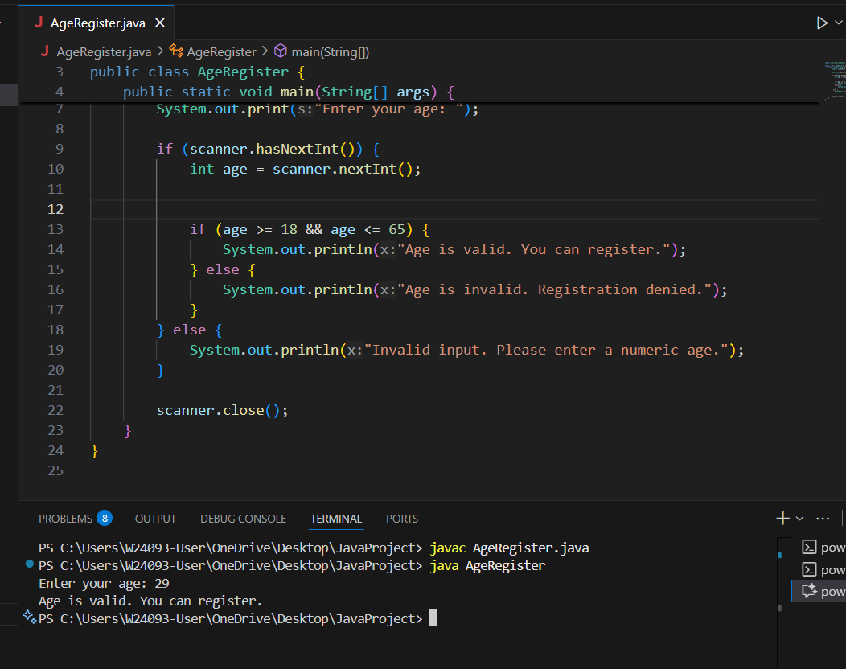

A: Excludes 18 and 65. Only valid for 19–64.

B: Correct. Includes both 18 and 65.

C: Technically correct. age > 17 → 18+, age < 66 → ≤65. Equivalent to Option B.

D: Incorrect.

Q2.
Answer is A.

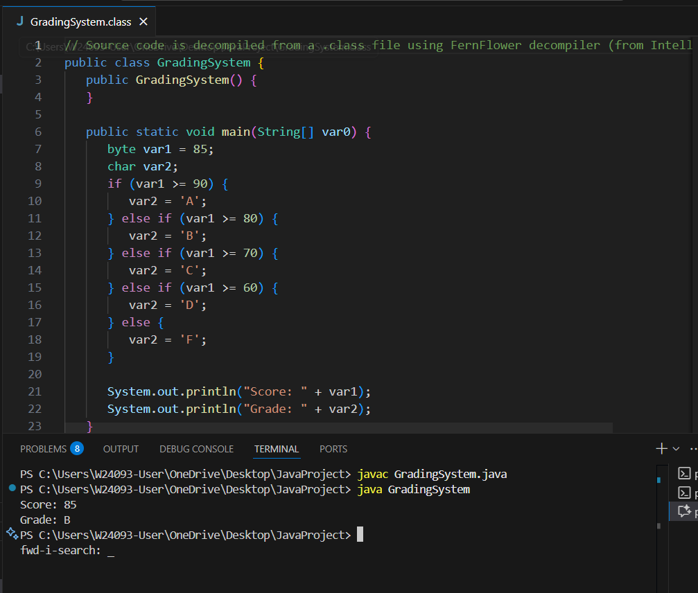

A: A is simplest and most readable.

B: Excludes exact scores 90, 80, 70, 60. Score 90 will not get an 'A'.

C: also correct but verbose.

D: D is efficient for integer scores but less intuitive.

Q3.
Answer is D.

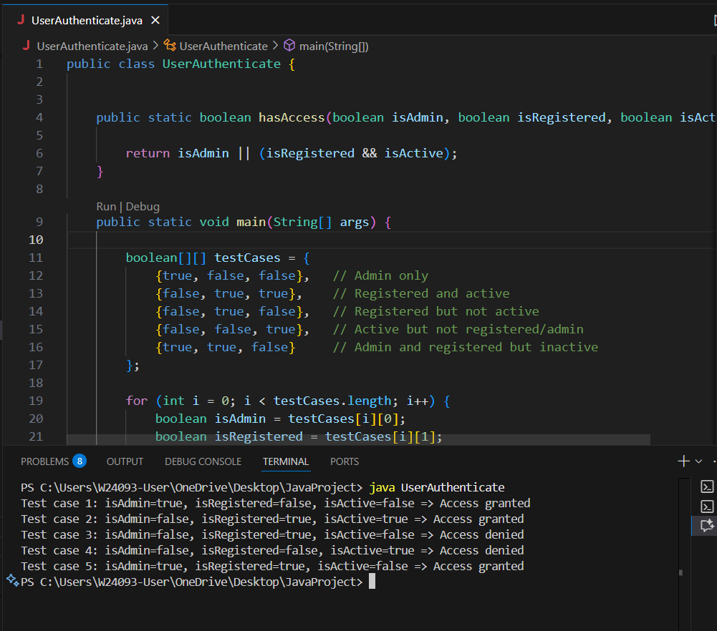

A: Correct but inefficient.

B: Incorrect.

C: Incorrect.

D: Correct and most readable.

Q4.
Answer is A.

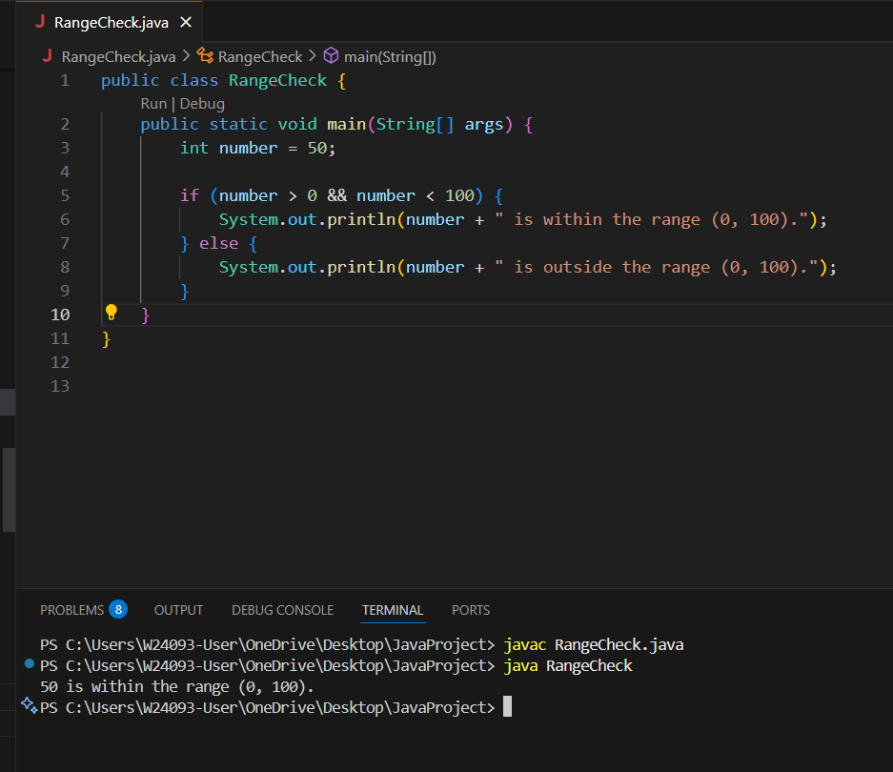

A: A is for exclusive ranges.

B: B is for inclusive ranges.

C: Used or. Wrong logic.

D: also wrong logic.

Q5.
Answer is C.

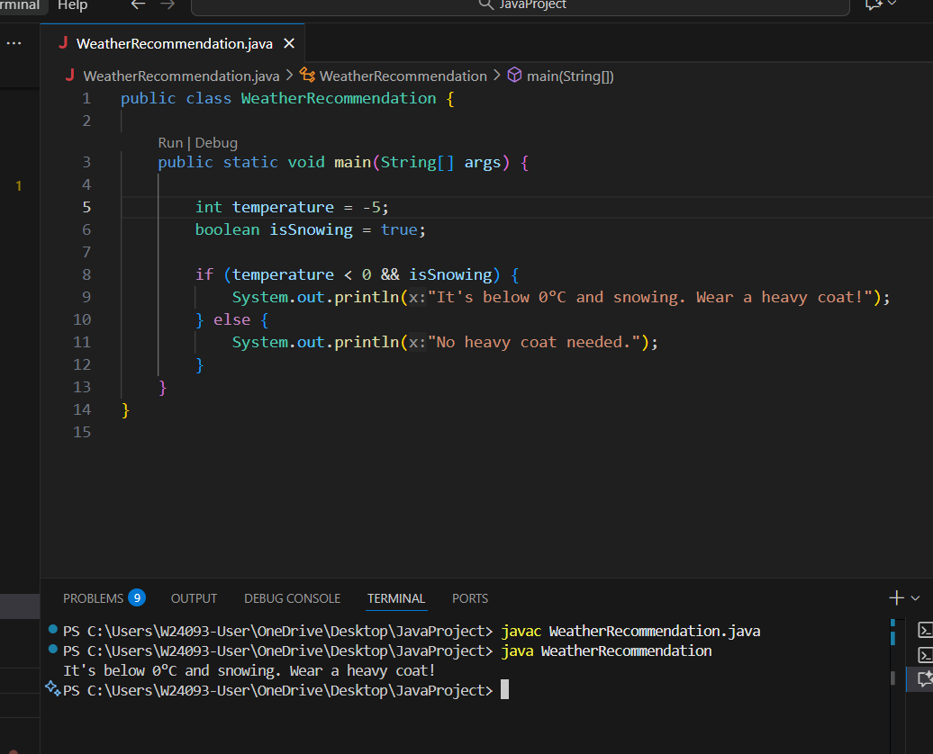

A: not what the problem wants.

B: it’s close, but not perfectly correct.

C: Perfectly correct.

D: Therefore, C and D are both correct in logic and behavior.

Q6.
Answer is A.

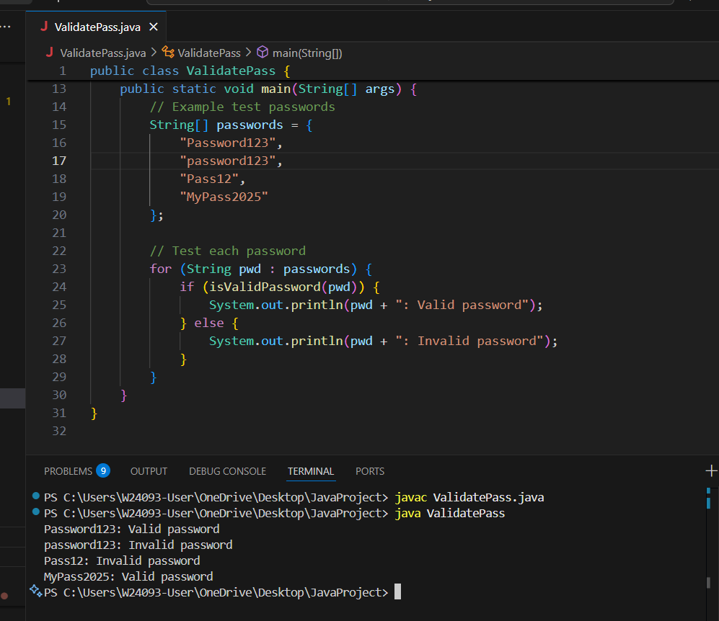

A: is correct.

B: Invalid.

C: No guarantee of upper/lower/digit

D: Works, but less clean than A.

Q7.
Answer is A.

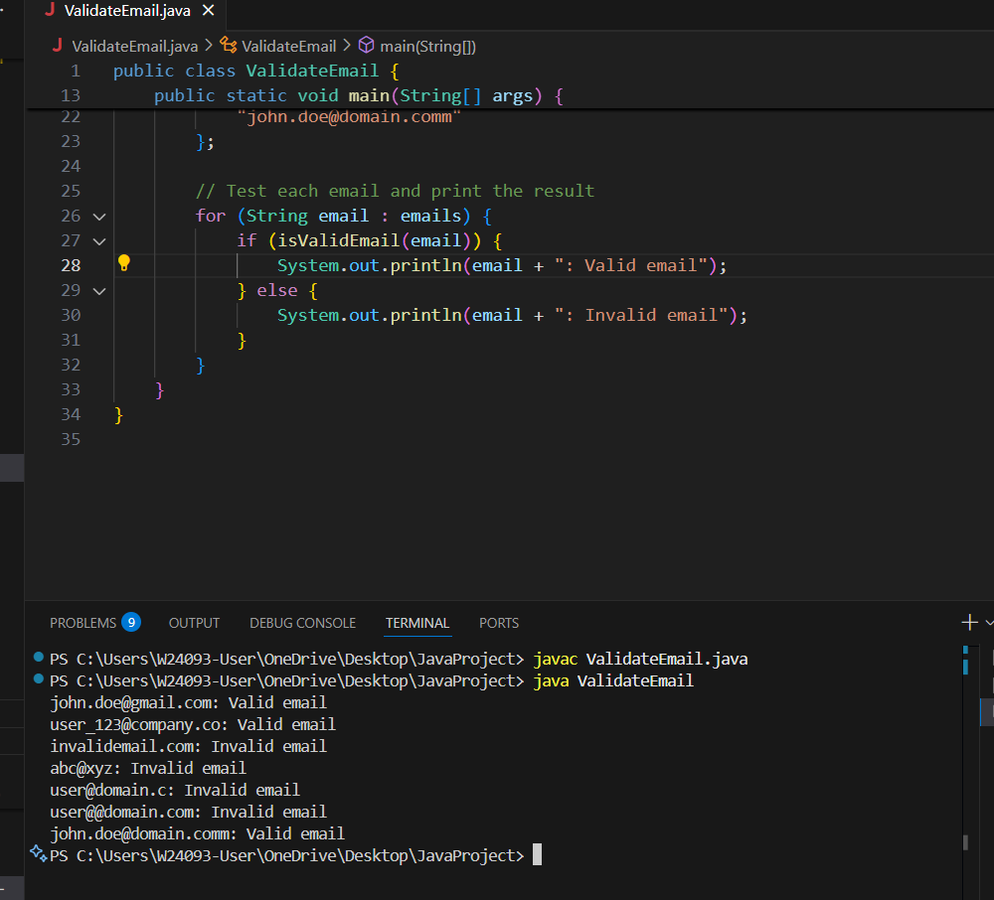

A: Correct structure.

B: Too simple — not strict enough.

C: doesn’t allow normal characters used in emails.

D: basically just checks contains @ and .

Q8.
Answer is C.

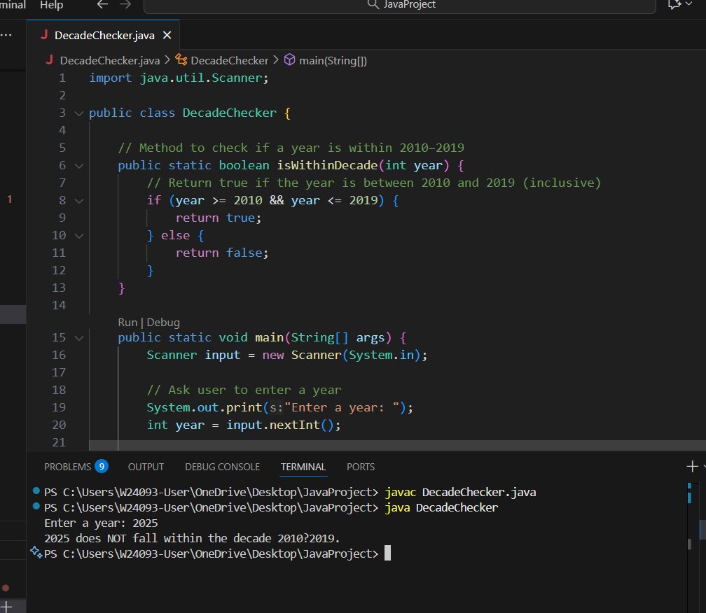

A: Works correctly, includes 2010–2019.

B: Confusing and unreliable.

C: Best and clearest.

D: Works, but slightly less clear than C.

